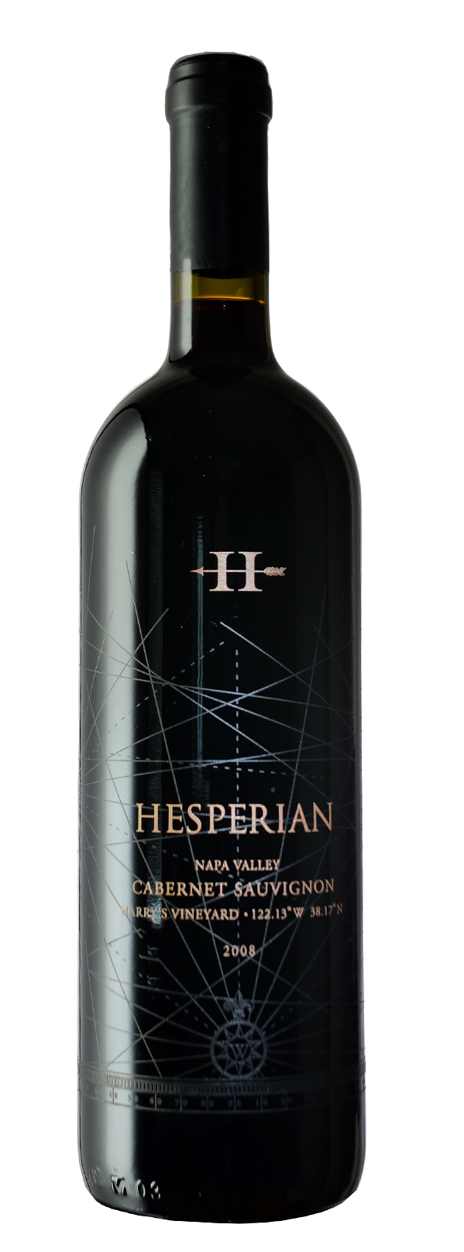

**Description:** Ruby colored with a lighter edge. A very complex and beguiling nose of plum, red cherry, orange rind, licorice, clove, nutmeg, floral notes like peony, sweet tobacco. The mouthfeel is super soft and rich with notes of blackberry, peppermint, salty caramel and a savory character. The finish is very long, seamless and juicy and savory with a pronounced earthiness.

Single Vintage Back Story: Before I purchased Kitoko Vineyard in 2010,  I bought fruit from several single vineyards to make and bottle wines that showcase the terroir of various appellations in the Napa Valley.  In 2008, I crafted only 50 cases of wine each from Larry's Vineyard on Mt Veeder, Jeff’s Vineyard in Yountville, Harry’s Vineyard in Coombsville and Tom's Vineyard in Rutherford.  I also made 450 cases of a Napa blend from the four vineyards.

Winemaking Style: The techniques I learned in Bordeaux are nowadays considered a bit old style but it is this style of winemaking that made the beautiful wines that came out of Bordeaux in the 80s and 90s. I maintain this style because I believe this is what makes for beautiful age-worthy wines. The 2008s are at a peak now and we thought it would be great to make an offer now, for the holidays.  Enjoy them together with family and friends.

**The Vintage**: The 2008 wines always had a lot of charm. They were and still are very generous and voluptuous. This is due to the weather of this vintage. It was a dry vintage with a spring frost that lowered yields across the valley. In August there were massive fires in northern California that produced enough smoke high in the atmosphere to create a haze that slowed down maturation which allowed us to have a longer hang time. These two elements are the reason why the 2008 are so voluptuous.

ALCOHOL:  14.7% CÉPAGE:  100% Cab Sauvignon ÉLEVAGE:  19 Months, 60 % new French Oak PRODUCTION:  50 cases OPTIMAL AGING: 2020-2030

**2008 Hesperian Cabernet Sauvignon**

*Harry’s Vineyard, Coombsville, Napa*